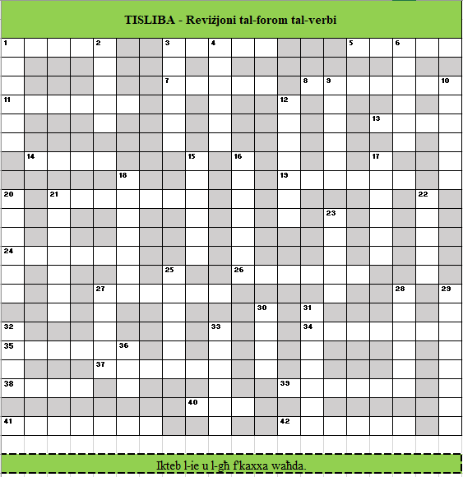

Nissel il-forma tal-verb mill-għerq u iktibha fit-tisliba.
Mimdudin |  |  |  |  | Weqfin
Numru | Għerq | Forma | Kelma |  | Numru | Għerq | Forma | Kelma
1 | b-s-r | 1 |  |  | 1 | b-r-d | 2
3 | w-ż-n | 3 |  |  | 2 | r-q-d | 1
5 | b-r-x | 1 |  |  | 3 | w-s-l | 2
7 | s-f-j | 2 |  |  | 4 | ż-f-n | 2
8 | b-ż-q | 7 |  |  | 6 | r-ż-n | 2
11 | r-s-s | 2 |  |  | 9 | r-għ-d | 6
13 | ġ-r-r | 1 |  |  | 10 | q-r-t-s | K1
14 | b-l-h | 9 |  |  | 12 | f-s-l | 5
19 | s-d-d | 2 |  |  | 15 | f-r-d | 2
21 | k-s-r | 5 |  |  | 16 | s-m-t | 7
24 | x-n-d-r | K1 |  |  | 17 | b-s-r | 2
26 | t-r-f | 2 |  |  | 18 | s-r-q | 7
27 | q-t-l | 7 |  |  | 20 | b-x-q | 2
34 | b-ħ-b-ħ | K2 |  |  | 21 | b-n-d-l | K2
35 | b-r-q | 2 |  |  | 22 | ħ-b-t | 1
37 | q-r-b | 2 |  |  | 23 | ħ-r-t | 1
38 | ħ-l-l | 1 |  |  | 25 | s-b-r | 8
39 | d-r-b | 7 |  |  | 27 | n-f-q | 1
40 | f-w-r | 1 |  |  | 28 | ħ-b-b | 2
41 | r-b-t | 7 |  |  | 29 | ħ-r-ġ | 10
42 | m-għ-k | 6 |  |  | 30 | x-m-m | 1
 |  |  |  |  | 31 | r-d-m | 7
 |  |  |  |  | 32 | s-b-ħ | 9
 |  |  |  |  | 33 | s-b-r | 2
 |  |  |  |  | 36 | q-w-m | 1

